Steps to be followed

# Create new Gmail account with “less secure apps” options in ON.

# Installed required python packages

# Replace the required fields in Source code as per your requirement and run it.

## Create new Gmail account with “less secure apps”

After creating new Gmail account, go to <https://myaccount.google.com/> and to Security option.

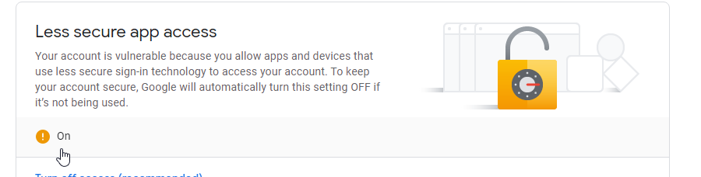

Set it to ‘ON’.

This is the reason to create new Gmail account, since we are enabling ‘less security apps’ to access.

## Install required python packages

Install requests, json packages as per your system configuration.

### 